Sorting in Constant Number of
Row and Column Phases on a Mesh

John M. Marberg and Eli Gafni
Algorithmica (1988) 3 : 561-572
1. Thory
0-1 principle ( The Art of Computer Programming Vol. 3, Knuth ):
ability to sort any binary sequence of n bits
= ability to sort any n numbers

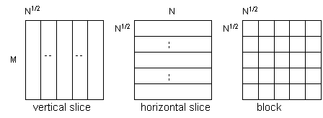
2. Algorithm
assumn M=2^{S},N=2^{2T},S>=T

Balance(v,w) {operate on vxw matrix}
(a) sort columns downward
(b) ratate each row k, k mode w position right
(c) sort columns downward
~ Balance the distribution of the 0’s and 1’s among the columns
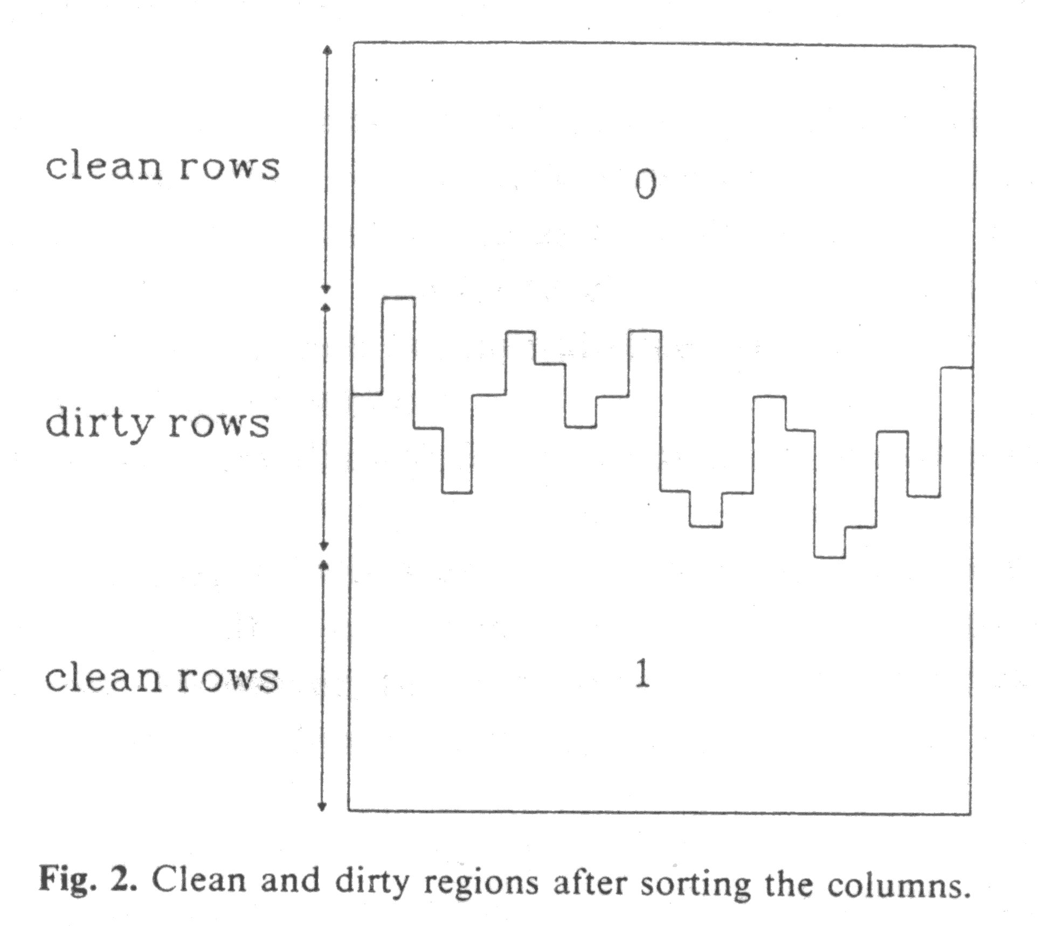
-> reduce to min(v,w) dirty rows

Unblock {operate on entire mesh}
(a) ratate each row k, k*N^{1/2} mod N position right
(b) sort columns downward
~ Distribute the elements of each block among all the columns
k dirty blocks -> k dirty rows at most

Shear {operate on entire mesh}
(a) sort even rows to the right , sort odd rows to the left
(b) sort columns downward
~ Assume all dirty rows in a continuous region
each pair of adjacent dirty rows -> 1 clean row + 1 possible dirty row
k dirty rows -> k/2 dirty rows

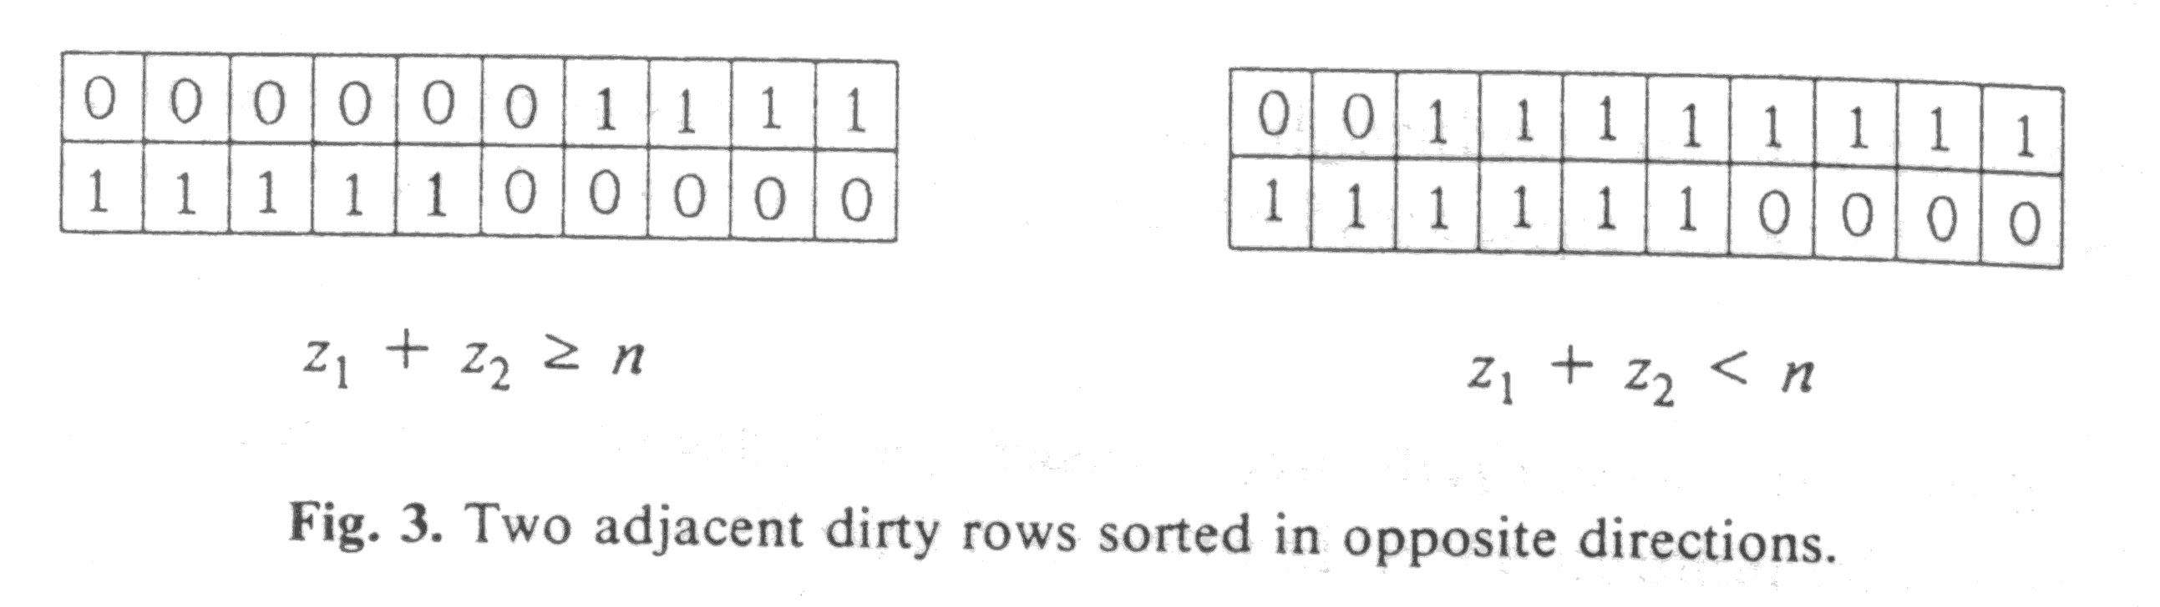
Rotate Sort :
step 1: Balance each vertical slice
{ at most 2N^{1/2} dirty blocks }
step 2: Unblock the mesh
{ at most 2N^{1/2} dirty rows }
step 3: Balance each horizontal slice as if it were a N x N^{1/2} mesh lying
on its side
{ at most 6 dirty blocks }
step 4: Unblock the mesh
{at most 6 dirty rows }
step 5: Shear three times
{at most 1 dirty rows }
step 6: Sort rows to the right
{ the mesh is sorted }

3.Conclude
Rotate + Sort -> Sort -> compare/exchange (odd-even transposition sort)
O(M+N) parallel steps ~Optimal lower bound for sorting on a mesh
16 row/column phases

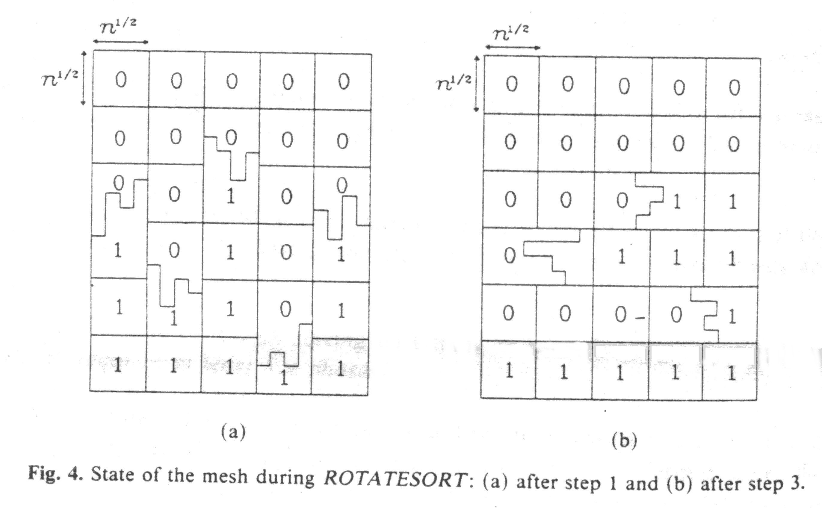

Created by : Seng-I Yeh
Date : Oct. 11 , 1999

